Create the Employees Table
CREATE TABLE Employees
(
EmployeeID INT AUTO_INCREMENT PRIMARY KEY,
FirstName VARCHAR(50),
LastName VARCHAR(50),
DepartmentID INT,
Salary DECIMAL(10,2),
JoinDate DATE
);

Insert Sample Data
INSERT INTO Employees
(FirstName, LastName, DepartmentID, Salary, JoinDate)
VALUES
('John','Smith',1,50000,'2022-01-10'),
('Alice','Brown',2,60000,'2021-03-15'),
('David','Wilson',1,55000,'2023-06-20'),
('Emma','Taylor',3,70000,'2020-08-05'),
('Rahul','Sharma',2,65000,'2024-01-15');

Create the Stored Procedure - This procedure returns the total number of employees in a given department.
DELIMITER $$
CREATE PROCEDURE sp_CountEmployeesByDepartment
(
IN p_DepartmentID INT
)
BEGIN
SELECT COUNT(*) AS TotalEmployees
FROM Employees
WHERE DepartmentID = p_DepartmentID;
END $$
DELIMITER ;
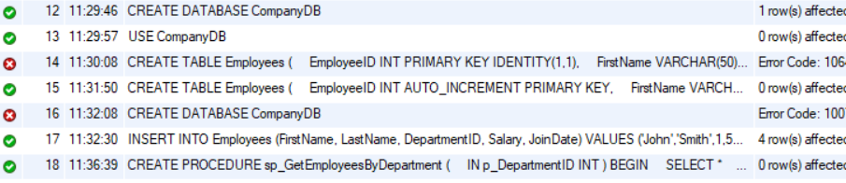

CALL sp_GetEmployeesByDepartment(1);
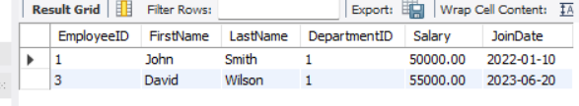

DELIMITER $$
CREATE PROCEDURE sp_CountEmployeesByDepartment
(
IN p_DepartmentID INT
)
BEGIN
SELECT COUNT(*) AS TotalEmployees
FROM Employees
WHERE DepartmentID = p_DepartmentID;
END $$
DELIMITER ;

CALL sp_CountEmployeesByDepartment(1);
